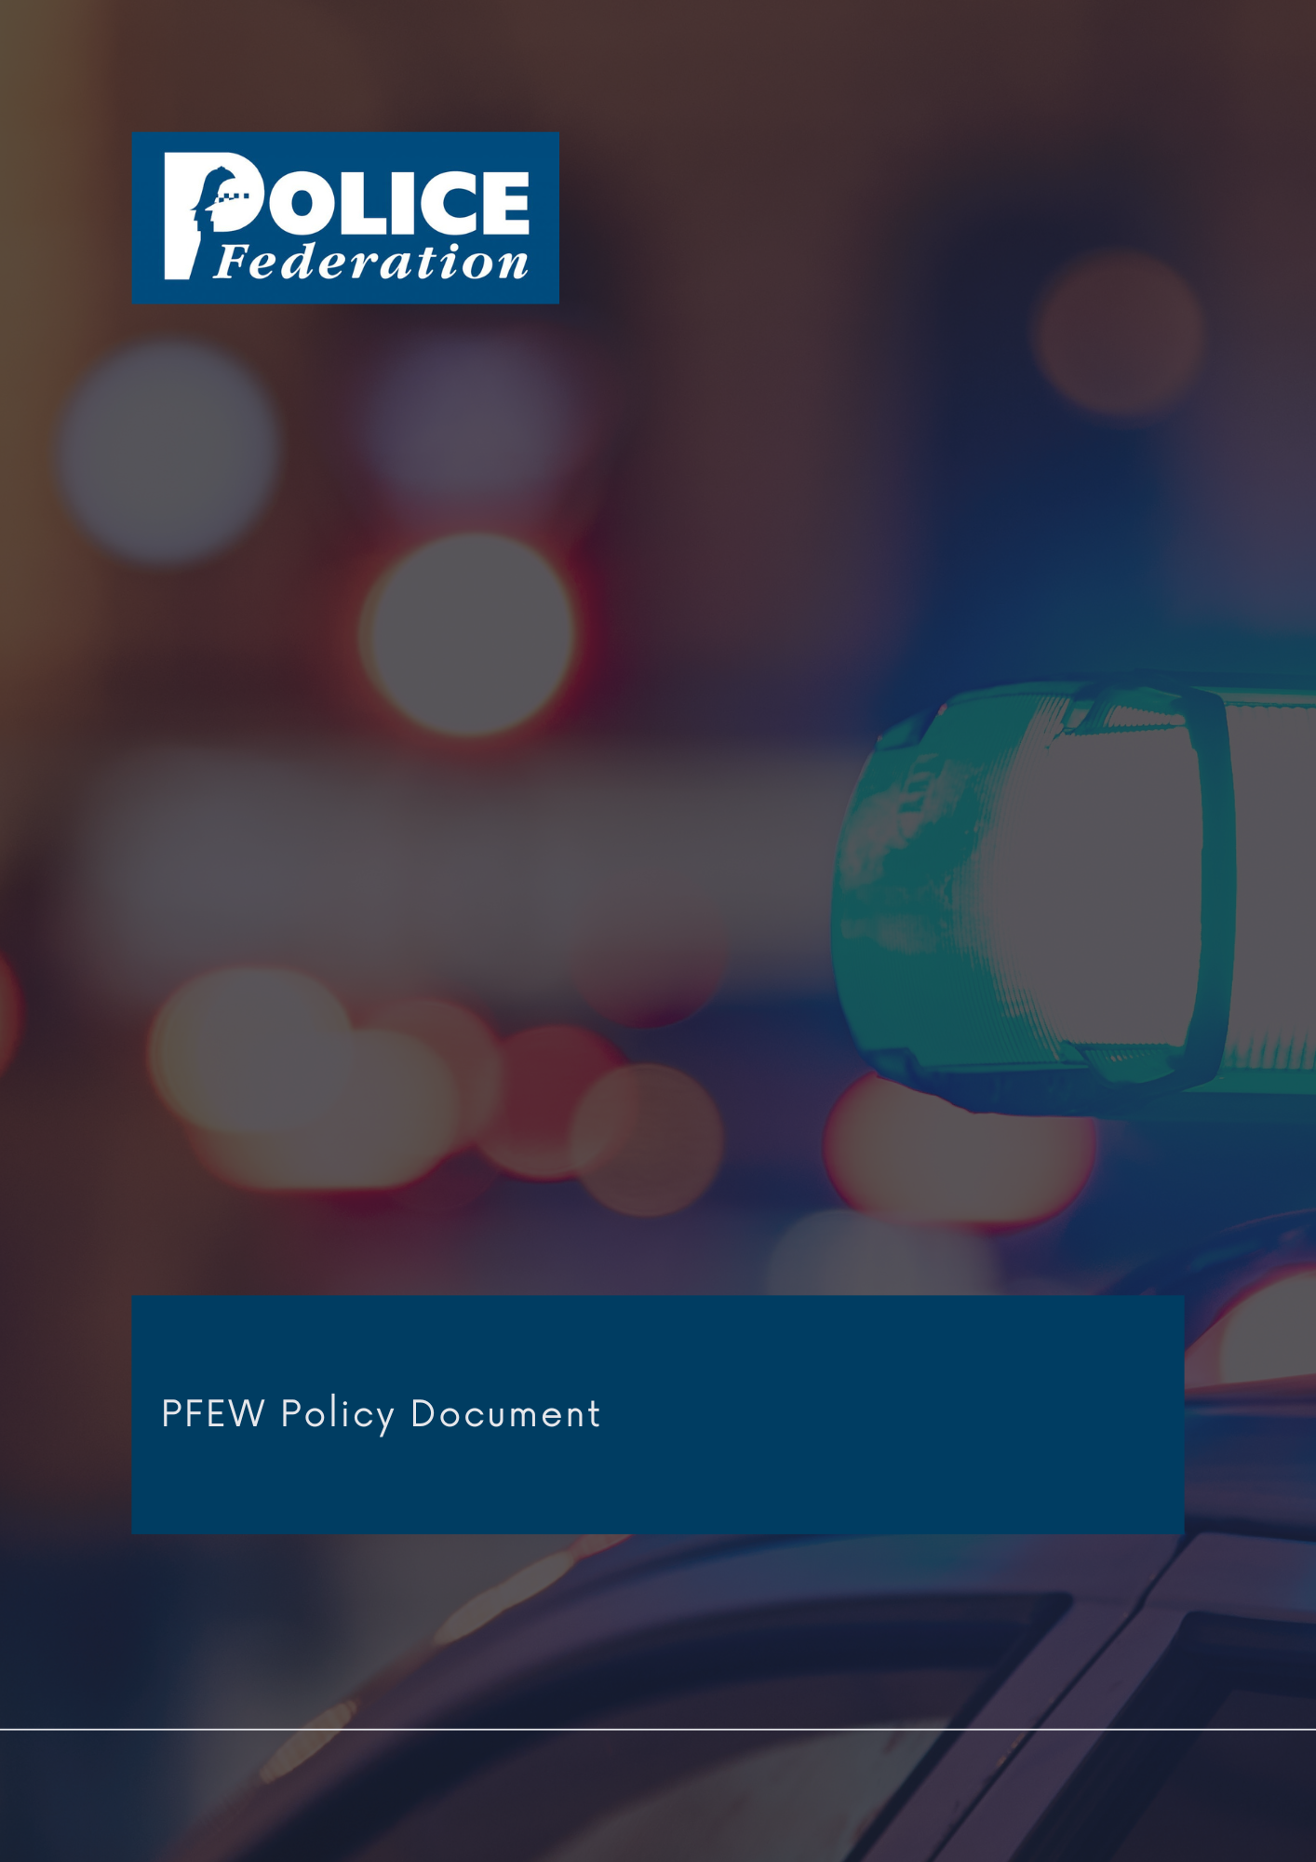
Near Miss Policy

2022
Version 1

The PFEW Policy Department has embarked on a concerted effort to formulate and/or revise policy documents, titled "Policy Refresh", on key topics concerning its members.
These strategic documents are evidence-based, aligned with PFEW's Business Areas, as well as championed by National Board members.
It is aimed for PFEW to maintain clear policy positions on key topics, that allows members to have clarity on PFEW's official position statements that are backed by evidence.
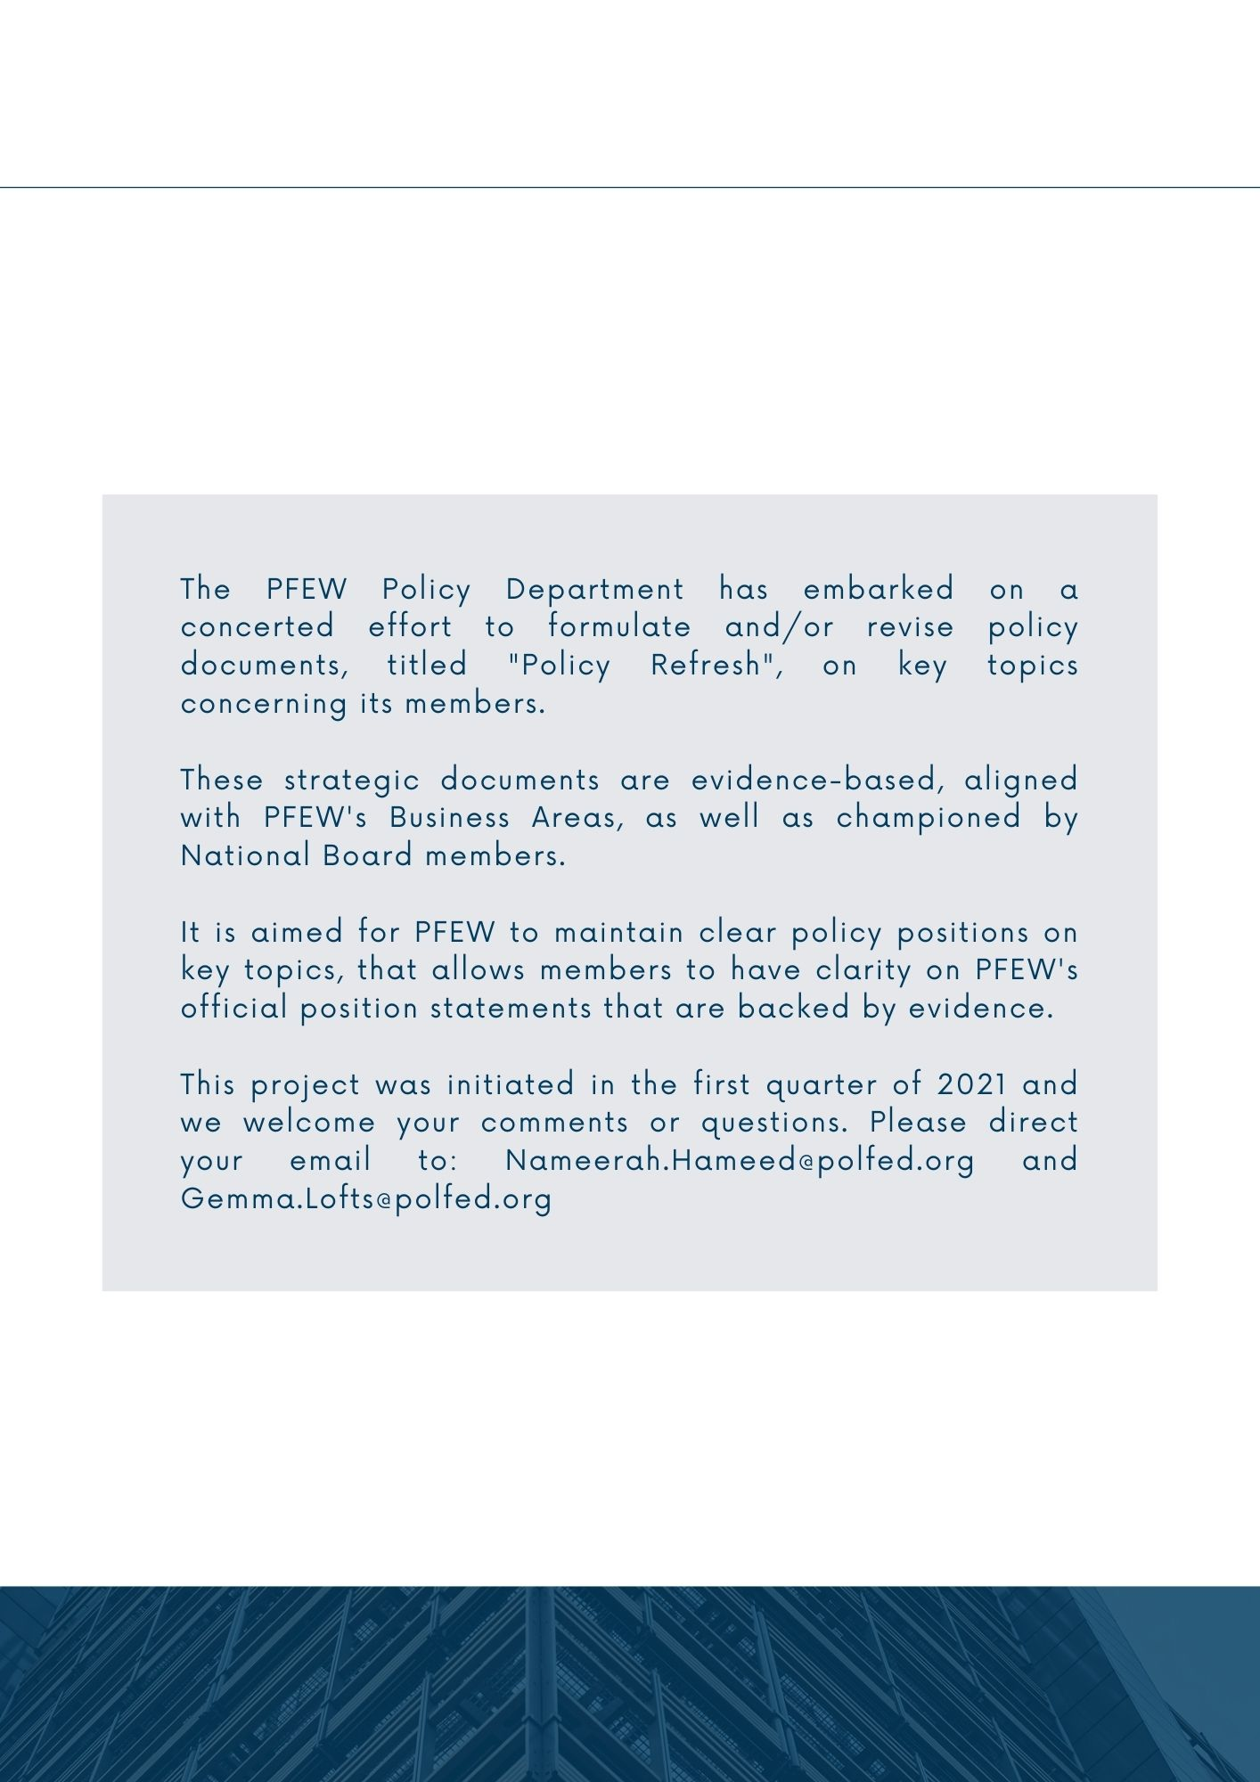

NEAR MISS POLICY
Version 1

Policy Principles and Rationale
This guidance has been produced to advise and inform PFEW Representatives and Members as to what constitutes a Near Miss and when they should be reported through their force systems. It is intended that this document will be updated periodically to incorporate any developments in this field.

Definition
A number of definitions as to what constitutes a Near Miss have been produced by different organisations which vary in detail. However, for the sake of clarity the definition used by PFEW is as follows:

“An event or situation that could have resulted in injury, illness, damage or loss but did not do so due to chance, corrective action or timely intervention.”

It follows from this definition that any event or situation which results in injury, illness, damage, or loss is not a near miss and should be reported as an accident/incident. This includes where an officer or member of staff is spat on.

Why should a Near Miss be Reported

- Legal Reasons

S2, The Health and Safety at Work etc. Act 1974 places a legal duty on employers (including police forces across England and Wales) “to ensure, so far as is reasonably practicable, the health, safety and welfare at work of all his employees.”

S7 (b) of the 1974 Act places a general duty on employees, when at work, to co-operate with their employer in health and safety matters.

- Moral Reasons

In common with all employees Police Officers are under a moral obligation to assist in preventing their colleagues and others from coming to harm in the workplace.

Academic research indicates that there is a relationship between the number of near misses which occur in a workplace and the incidence of injury and even death. It is vital therefore that employers put in place

robust procedures to record and, where appropriate, investigate near misses to learn from them and eliminate risks which, if they go unchecked, could result in injury or death.

Promoting the submission of near miss reports is indicative of an organisation which values the health, safety, and wellbeing of its employees.

Due to their greater numbers and greater involvement in operational policing, officers from the federated ranks are more likely to be exposed to near misses than senior managers.

- Financial Reasons

The Police budget is under unprecedented pressure, accidents can result in substantial costs including; compensation to injured or bereaved parties, replacing damaged equipment, legal costs and the payment of fines. Therefore, it is common sense to do what we can to prevent accidents from occurring in the first place.

Reporting
Some forces give detailed guidance and examples of incidents which should be recorded as a Near Miss including road traffic collisions and violent incidents which did not result in injury to officers.

PFEW’s position is that, by default, all incidents which meet the definition should be recorded and reported to supervisors. Where this can’t be done via internal automated systems, a written report should be made to your immediate supervisor.

Each force should hold regular health and safety meetings which are the proper forum for evaluating Near Miss reports and accidents. Individual officers, supervisors and managers should not discourage officers from submitting Near Miss reports.

Examples

Types of incidents which are of particular concern to the PFEW and should be recorded as Near Misses include:

- Premature failure of Airwave batteries.
- Failure of Airwave emergency buttons to obtain a response.
- Leaks or other failure of PAVA.
- PAVA, baton or other PPE having no or little effect during a violent incident (provided no injury occurred to officers or staff, if injury occurred it’s an accident).
- Falling asleep at the wheel of vehicles (personal or work) enroute to, during or on way back from tours of duty.
- Exposure to extremes of temperature/inclement weather.
- Breaches of Health & Safety law, particularly provisions of the Workplace (Health, Safety and Welfare) Regulations 1992, which cover areas including the heating and ventilation of buildings and the provision of facilities for washing and taking refreshment breaks, or the Provision and Use of Work Equipment Regulations 1998 (PUWER – which places a legal obligation on police forces to ensure that equipment issued to allow you to carry out your duties must be fit for purpose).
- Vehicle faults which endanger safety e.g, engines cutting out whilst in motion, brake failures, vehicle fires. Such vehicles should be withdrawn from service and faults reported to vehicle workshops immediately.
- Building defects or damage which could cause injury or ill health, line managers should be notified of such defects and estates department contacted to remediate the same.

Resourcing Difficulties
The HSE has adopted the position that the specific deployment of resources is a matter for Chief Constables, and they will not dictate resource levels to management, however, there are a number of occasions where a lack of resources can constitute a near miss:

- Deployment of clearly inadequate numbers of officers to deal with a specific incident e.g. deploying a single unit to deal with a large scale violent incident with no available “back up”.
- Failure to react to information around the need for additional officers to respond to developing situations which present a risk to safety.
- Deployment of non-specialist officers to incidents or tasks which should be dealt with by specialists. e.g. untrained officers being sent to incidents on fast roads (speed limit of 50mph plus) due to lack of Roads Policing resources, particularly where the officers do not have access to suitable clothing and equipment. NB due to the nature of policing non-specialist officers will come across incidents like this and will be expected to deal with them to the best of their abilities until relieved by specialist officers.
- Where an incident escalates and there is a lack of available specialist resource to conclude the incident safely e.g. no dogs available for ground searches or public order incidents.
- Officers not being able to take refreshment breaks due to lack of resources can constitute a near miss. It is acknowledged that operational demands may prevent officers from receiving a break during a shift. However, this should be the exception and not the rule. Officers who are tired, hungry, or dehydrated are at greater risk of being involved in an accident. Where an officer is prevented from receiving a full refreshment break more than once in a run of shifts (i.e. a series of shifts rostered on consecutive days between sets of scheduled Rest Days) this should be recorded as a near miss.

Police forces are obliged to make “all efforts” to ensure that officers receive the breaks that they are entitled to under Police Regulations 2003 and Working Time Regulations 1998. Due cognisance must be taken of any Health and Safety implications in not giving an officer the rest break to which they are entitled.

Failure to provide adequate rest breaks may also be unlawful discrimination under the Equality Act 2010 in that it may disproportionately affect disabled colleagues, e.g. those with conditions such as diabetes. Working shifts is also thought to increase the risk of developing diabetes and to mitigate this, it is vital that facilities and time are provided to allow for the preparation and consumption of a healthy meal.

Scope of the Policy
This policy applies to all PFEW members and representatives.

Key Stakeholders
- The National Police Chiefs' Council (NPCC)
- The Association of Police and Crime Commissioners (APCC)
- Home Office, UK Government
- PFEW Membership
- Local Branch Chairs and Secretaries
- Her Majesty's Inspectorate of Constabulary and Fire Service (HMICFRS)
- College of Policing
- Police Superintendents' Association (PSA)
This is not an exhaustive list

Policy Review
Recommend to review after the 12-month period.

Policy Document – Versions
Version 1 | Drafted by PFEW | Policy Approved on 29/09/2022 | Policy to be revised in 12 months

Approved by National Board on 29th September 2022

